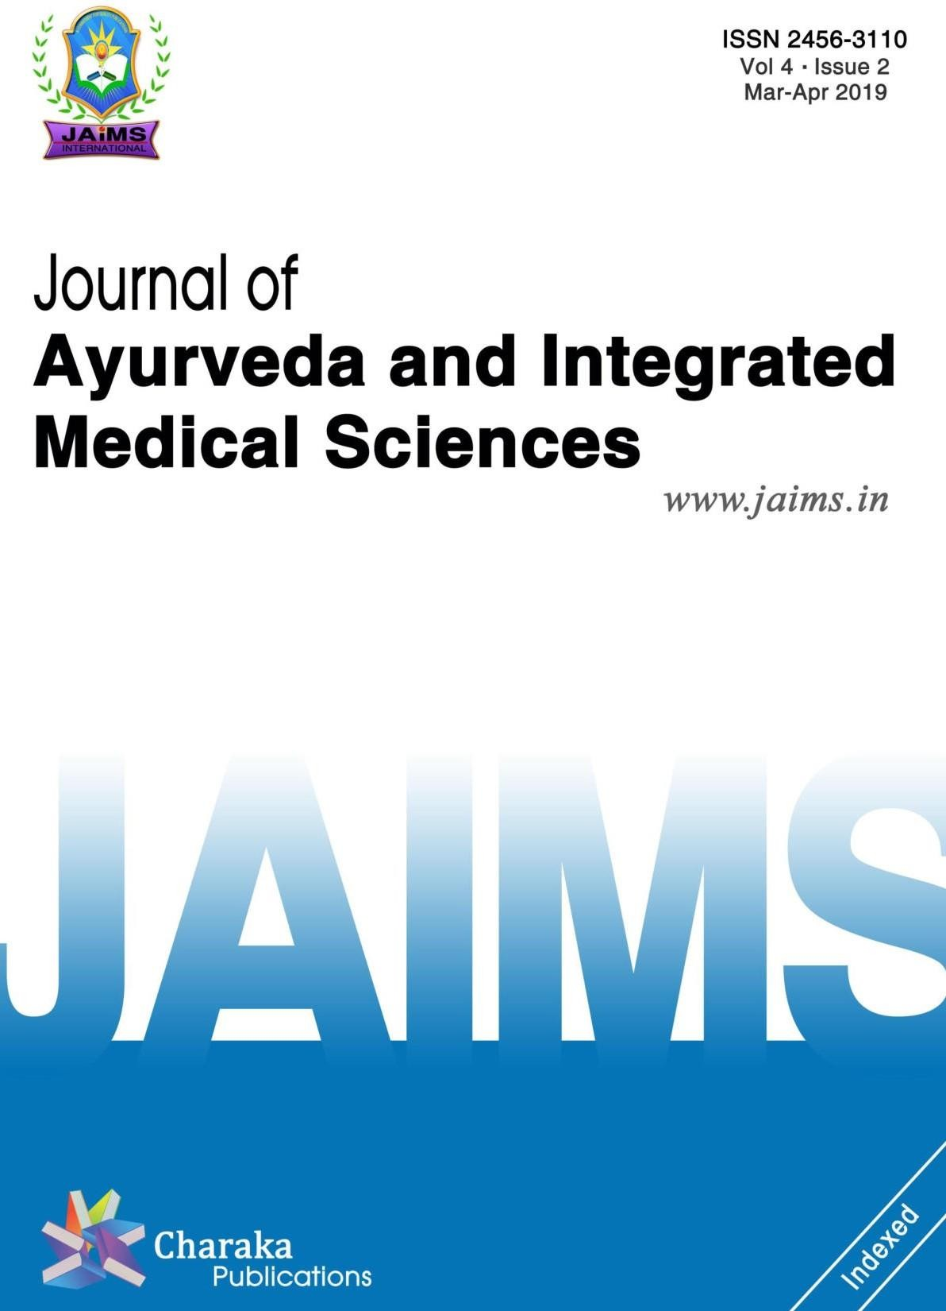



A B S T R A C T

Ayurveda is the flawless, authentic ancient science of life and is genuinely called the “Mother of all healing.” The knowledge of Ayurveda was originated in India for more than five thousands years ago. The word *Ayu* literally means life and *Veda* the science or knowledge. Ayurveda stands for knowledge of life. *Stanya* is *Updhatu* of *Rasa Dhatu*. *Rasa Dhatu* is said to be *Aadi Dhatu* i.e. *Pratham Dhatu*. Ayurveda explains the importance of *Stanya* (Breast Milk) through its main function *Pushti* and *Jeevan* (growth and life). If *Rasa Dhatu* formation is disturbed, its *Updhatu Stanya* will also be disturbed. Now in modern era most of the cases of *Stanya Kshaya* are observed. So in present study *Madhuk Churna* and *Vidarikand Churna* are used in the management of *Stanya Kshaya.*

**Key words:** *Stanya Kshaya, Vidarikand Churna, Madhuk Churna.*

# INTRODUCTION



**ISSN: 2456-3110**

**ORIGINAL ARTICLE**

Mar-Apr 2019

**A Comparative study of *Madhuk Churna* with**

***Vidarikanda***

***Stanyakshaya***

***Churna***

**in**

**the**

**management**

**of**

**Dr. Pravin A. Patil,1 Dr. Anjali N. Lade,2 Dr. Chetna J. Kulkarni3**

***1****Assistant Professor, Dept. of Rasashastra Avum Bhaishajya Kalpana, ASPM'S Ayurvedic College Hospital Research Institute, Buldana, 2Post Graduate Scholar, 3Professor, Dept. of Prasuti Tantra Avum Stri Roga, SVNHT Ayurved College, Rahuri, Maharashtra, INDIA.*

*Stanya Kshaya* is one of the diseases which has been given prime importance in Ayurveda literature. The *Stanya***[1]** is *Jeevana Amsha* as it is the chief source of nutrition and diet to the infant due to *Satmyatva*. Breast milk is the nector to the child, which gives many benefits to mother and child. Breast milk is ultimately the best source of nutrition for new born baby.**[2]** Breast milk is composed of immunoglobuline IgA, Fat, Proteins Carbohydrates, Minerals, Digestive

**Dr. Pravin A. Patil**

Assistant Professor, Dept. of Rasashastra Avum Bhaishajya Kalpana, ASPM'S Ayurvedic College Hospital Research Institute, Buldana, Maharashtra, INDIA.

**E-mail:** [drpravinpatil15@gmail.com](mailto:drpravinpatil15@gmail.com)

Submission Date: 12/02/2019 Accepted Date: 23/03/2019

enzymes, Antibodies. So breast milk is best than any

other type or feeding.**[4]** Ayurveda emphasises prevention of disease, rejuvenation of our body systems and extension of life span. The objects of this science is the maintenance of the equilibrium of tissue elements. According to Ayurveda, breast feeding is the easiest and the healthiest way to feed a newborn, as the milk is rich in nutrients.**[3]** In this study the role of *Vidarikand Churna* and *Madhuk Churna* was studied in 60 patients of *Stanya Kshaya* and its effectiveness is seen.

**Address for correspondence:**

# OBJECTIVES

To study the efficacy of *Madhuk Churna* and *Vidarikanda Churna* in the management of *Stanya Kshaya*.

|  |  |
| --- | --- |
| **Access this article online** | |
| **Quick Response Code** | **Website:** [**www.jaims.in**](http://www.jaims.in/) |
|  |
| **DOI: 10.21760/jaims.4.2.3** |

# MATERIALS AND METHODS

Present study is randomised prospective clinical trial. In this study 60 patients were divided randomly into two equal group named as Group A (Trial Group) and Group B (Control Group).

# SELECTION CRITERIA

**Inclusion Criteria**

The selection of patient was random but it was based on following conditions;

1. Age group in patient between 20 to 35 years.
2. Patient from 7th day of delivery.
3. The selection was irrespective of the parity, caste and religion.
4. Patients of *Stanya Kshaya* in *Sutikawastha*.
5. Patients with previous history of lactation deficiency.
6. Mother who had stress or any mental tension like Puerperal psychosis.

# Exclusion criteria For mother

vitiation of *Dhatus*, pregnant, suffering from fever, emaciated (*Shosha*), obese and has consumed diet likely to produce *Vidaha* (burning sensation or indigestion) or the edibles opposite in character should not give breast feed to the children.

# Grouping and randomization of patients

|  |  |  |
| --- | --- | --- |
| **Group** | **Group A** | **Group B** |
| **Drug** | *Madhuk Churna* | *Vidarikand Churna* |
| **Dose** | 5gm B.D | 5gm B.D |
| **Route** | Oral | Oral |
| **Anupana** | *Godugdha* 100 ml | *Godugdha* 100 ml |
| **Duration** | 28 days | 28 days |

60 patients were observed and treated (two groups of 30 patients each)

# Group A [Trial Group]

Trial group of 30 patients were given *Madhuk Churna*

with *Godugdha*.

# Group B [Control Group]

Control group of 30 patients were given *Vidarikanda Churna* with *Godugdha*.

# Assesement Criteria

Assesement criteria is done on the basis of following symptoms

1. *Mata Stanamalanata.*
2. *Balak Sharir Bhara.*
3. *Nidra.*
4. *Rodan.*
5. *Mala Pravrutti.*
6. *Mootra Pravrutti.*
7. *Kshudha Vruddhi.*
8. Patients who were having any pathology or disease i.e. Breast abscess, Mastitis, Breast atrophy, Cancer.
9. Systemic diseases Ex. Severe anaemia, hypertension, diabetes, infections diseases such as pulmonary tuberculosis, AIDS (where disease was extensive and progressive).

# For Baby

1. Premature baby (baby cannot suck)
2. Congenital anomaly i.e. cleft palate
3. Very ill baby.
4. Still born baby.

In exclusion criteria, *Stanapana Varjit Awastha,* The woman who is hungry, stricken with grief, tired, has

# OBSERVATION AND RESULTS

The analysis of these patients is being presented here,

# Table 1: Comparative effect of therapy

|  |  |  |  |  |  |
| --- | --- | --- | --- | --- | --- |
| **Parameter** | **Effect of therapy** | | | | **Comp ara tive effica cy** |
| **Group A** | | **Group B** | |
| **Remar k** | **Mean % improve ment** | **Remar k** | **Mean % improve ment** |
| *Mata Stanamala nata* | Marke d | 93.33 % | Marke d | 100.00% | Equall y Effecti ve |
| *Stanyaprav artan* | Marke d | 98.08 % | Marke d | 100.00% | Equall  y Effecti |

**DISCUSSION**

In present study out of 60 patients in control group and trial group there is significant improvement. Considering the symptom *Mata Stanmalanta,* group A patients got 93.33% of relief where as Group B patients got 100% relief. Group A patients got 98.08% increase in *Stanyapravartna* where as Group B patients got 100% increase in *Stanyapravartan* symptoms. In both Group patients there is 100% increase in weight of their children. Also Significantly increase in sleep of children in both groups was found. Also *Rodan* of child is significantly decreased in both group. Also *Mutrapravrutti* and *Mala Pravrutti* in children significantly increased in both Groups. So we can say that both *Vidarikanda Churna* and *Madhuk Churna* are effective in reducing the symptoms of *Stanya Kshaya* disease.

# CONCLUSION

Breast milk is the best gift a mother can give her baby. Significant and long term health benefits are associated with breast feeding for the individual mother, baby and society. Breast feeding is the ideal

way to feed babies. *Stanya Kshaya* is the common problem noticed in our clinical practice *Madhuk* and *Vidarikanda* are drugs of choice for *Stanyajanana*. From the present study, it can be concluded that *Madhuk Churna* (Trial drug) is effective on *Stanya Kshaya*. Since in the symptom *Stana Mlanata* treatment given to Group B (*Vidarikanda Churna*) shows slightly better results over treatment given to Group A (*Madhuk Churna*) but in the rest symptoms, *Stanya Pravartan, Balak Sharir Bhar, Nidra, Rodan, Mutrapravrutti* and *Malapravrutti* treatment given to group A and group B shows an average equal effects. Hence we conclude that treatment *Vidarikanda Churna* given to group B and *Madhuk Churna* given to group A are equally effective in disease *Stanya Kshaya*. In both group A and B this treatment does not show any toxicity. This treatment does not show any side effects during follow up. This remedy is cheaper in cost and easy to use, store, carry and can be used by poor class women also. *Madhuk* being a *Rasayana Dravya* aims at enriching the quality of the *Dhatus* or tissues but it requires a sincere and honest approach towards the use of this *Dravya* to get the fruitful outcomes. For this *Yukti* is the single most quality of Physician. This prestigious *Dravya* is honestly helpful in treatment of *Stanya Kshaya* as it is the most celebrated Ayurvedic herb and is renowned for its lots of benefits. Results of this study are encouraging. Thus more research in this work is necessary, to boost up the result which can serve the mankind.

# REFERENCES

|  |  |  |  |  |  |
| --- | --- | --- | --- | --- | --- |
|  |  |  |  |  | ve |
| *Balak Sharir Bhara* | Marke d | 100.00 % | Marke d | 100.00.% | Equall y Effecti ve |
| *Nidra* | Marke d | 80 .70 % | Marke d | 79.31 % | Equall y Effecti ve |
| *Rodan* | Marke d | 95 .74 % | Marke d | 96.00 % | Equall y Effecti ve |
| *Mutra Pravrutti* | Marke d | 89.80 % | Marke d | 96.15 % | Equall y Effecti ve |
| *Mala Pravrutti* | Moder ate | 50 .00 % | Moder ate | 50.00% | Equall y Effecti ve |

1. Sushruta Samhita, Ambikadutta Shastri, Chaukhambha Sanskrit Sansthan Varanasi, seventh edition 1989, Sharirsthan Adhyaya 5, shloka 8, page no71.
2. Sharangdhar Samhita, Acharya Sharangdhar, Sri Baidhyanath Ayurved Bhavan, 4th edition, 1994 Pratham Khand Adhyaya 5, shloka 10, page no 242.
3. Harit Samhita, Acharya Pandit Ramavalamb Shastri, Pratham Sthan, Adhyaya 2, shloka 17, page no 116.
4. Textbook of obstetrics Neonatology and Reproductive and child Health Education, C.S. Dawn, 16th Edition, 2003

**How to cite this article:** Dr. Pravin A. Patil, Dr. Anjali N. Lade, Dr. Chetna J. Kulkarni. A Comparative study of Madhuk Churna with Vidarikanda Churna in the management of Stanyakshaya. J Ayurveda Integr Med Sci 2019;2:11-14.

<http://dx.doi.org/10.21760/jaims.4.2.3>

**Source of Support:** Nil, **Conflict of Interest:** None declared.

*******************************